Altium DBLib README

# Introduction

The Altium DBLib is a database-linked library for Altium. It is a database that creates unique parts of different values to make it easier to manage BOMs.

# How to Install

To install the dblib, you must first clone the repository. Ask a person in the club how to do so. We typically use Github desktop to control the git repository.

You must also install MySQL Connector/OBDC 8.0.12 (or whatever’s the latest), which is located at this [link](https://dev.mysql.com/downloads/connector/odbc/). Note: you do not need to sign in with an account to download.

To connect to the dblib, open the the Altium-Lib.DbLib file in Altium. This is to ensure that you can connect to the dblib successfully. If there are any issues, please check them in the errors section of the readme. Then, navigate to the libararies tab, shown below. Click install… and select install from file. Then select the DbLib file, as shown below.

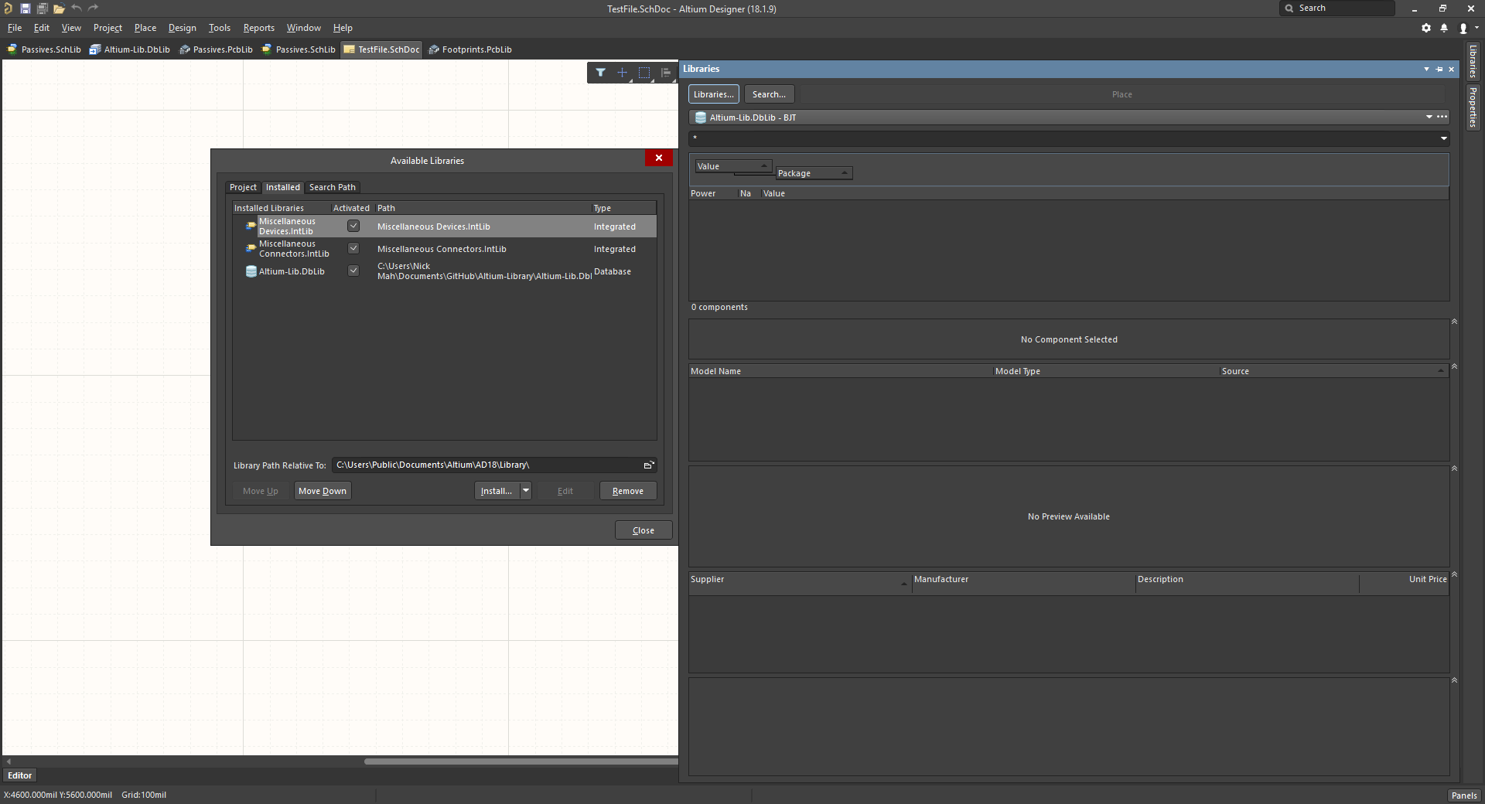

After installing the dblib, you should be able to see all the different tables, or libraries, as seen below. Again, if none of the libraries shown below are available, please check the issues section.

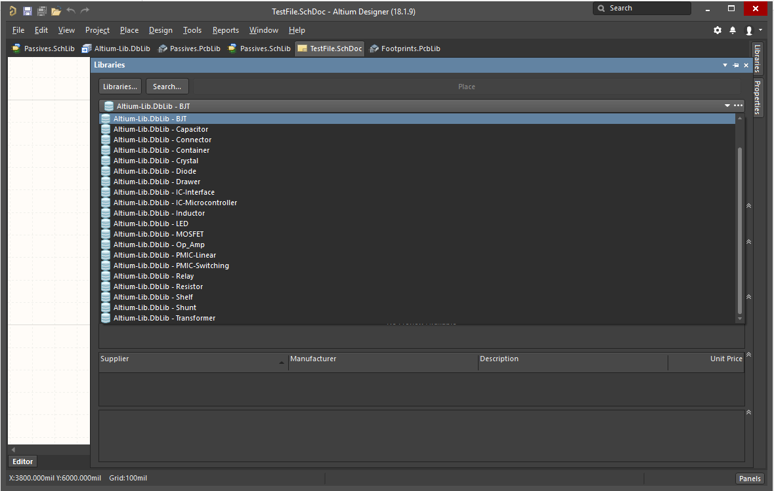

# How to Use

Everytime a part is added or modified, you will need to refresh library list in order to incorporarte the change. Because of this, it is recommended to refresh the library regulary. To do this right click in the libraries panel and click “refresh all” as shown below.

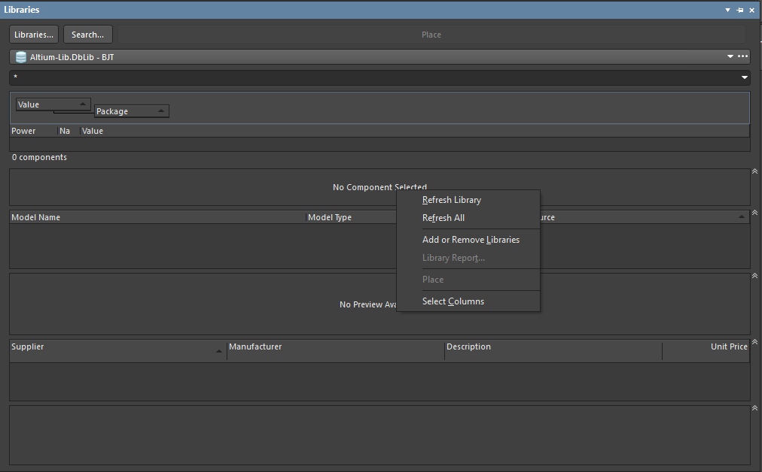

## Finding your part

The first thing to do is select the attributes of the part you want to look at. This can be done by selecting the “select columns” option after right clicking on the libraries tab, as seen in the figure above. Clicking on this will allow you to add different attributes to be shown.

In large libraries, it may be necessary to search filter your results. This can be done by dragging a column to the drag area, as shown below. This organize all parts in the library by that parameter first. In the figure below, all parts with a value of 1.0 will be tab, then 1.1 and so on. This is shown in the next figure below. Additionally, the search option at the top of the library tab can be used. However, loading this can be quite slow, however.

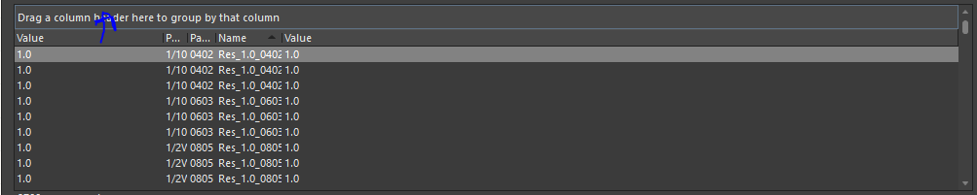

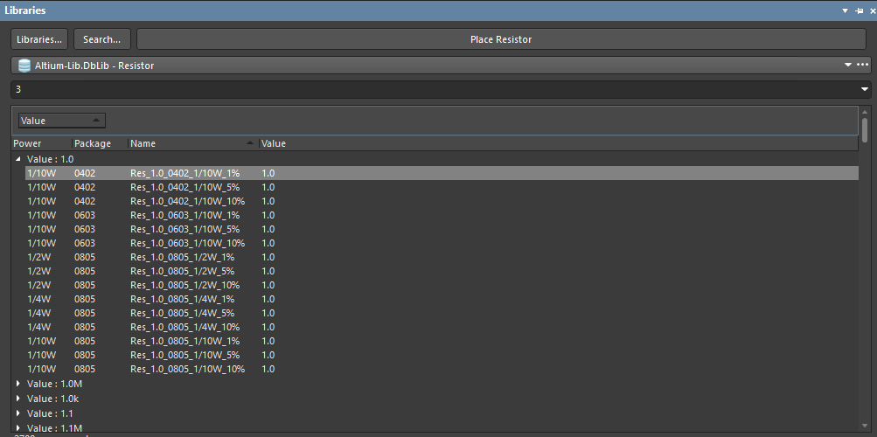

## Placing your part

Placing a part is the same as you would for normal Altium libraries. Simply drag the component onto the schematic.

## Adding a Part

In order to add a new component to the dbLib, I suggest you follow the readme from the AltiumDBFrontEnd repository.